- UK GDP was flat in July, which was a slightly better result than we had anticipated. But a combination of residual seasonality in the GDP series and strong headwinds suggests momentum in the economy is likely to peter out over the rest of this year.
- The economic outlook for 2026 looks fragile. Consumer spending power will be squeezed by weaker real income growth and the lagged impact of past interest rate rises for some mortgagors. Meanwhile, further tax rises are likely to be announced in the Budget, which will exacerbate the drag on the economy's near-term growth prospects.
This week's only major data release was the GDP estimate for July. Output was reported to have been flat during the month, with the sectoral breakdown showing some large offsetting movements.
Weaker activity in the manufacturing sector provided the largest drag, as unusually strong performances in a couple of the sub-sectors in June reversed. Elsewhere, consumer-facing services activity was flat, despite stronger output in the distribution sector after the month's pickup in retail sales. There were modest increases in output in construction and non-consumer-facing parts of the services sector.
Given monthly GDP data can be volatile and that July's reading came on the back of a hefty 0.4% m/m increase in June, the softer reading isn't a major cause for concern. Indeed, July's outturn was slightly better than we had anticipated. This was largely because the Office for National Statistics reported that health output rose 0.4% m/m in July, despite there being five days of strike action by resident doctors at the end of the month. We think it's very difficult to reconcile a pickup in activity in the sector with NHS England reporting that 76,394 working days were lost due to the dispute, causing 6,420 inpatient procedures and 47,676 outpatient appointments to be cancelled.
Chart 1: We think residual seasonality flattered the performance in H1 2025, and payback is likely in H2
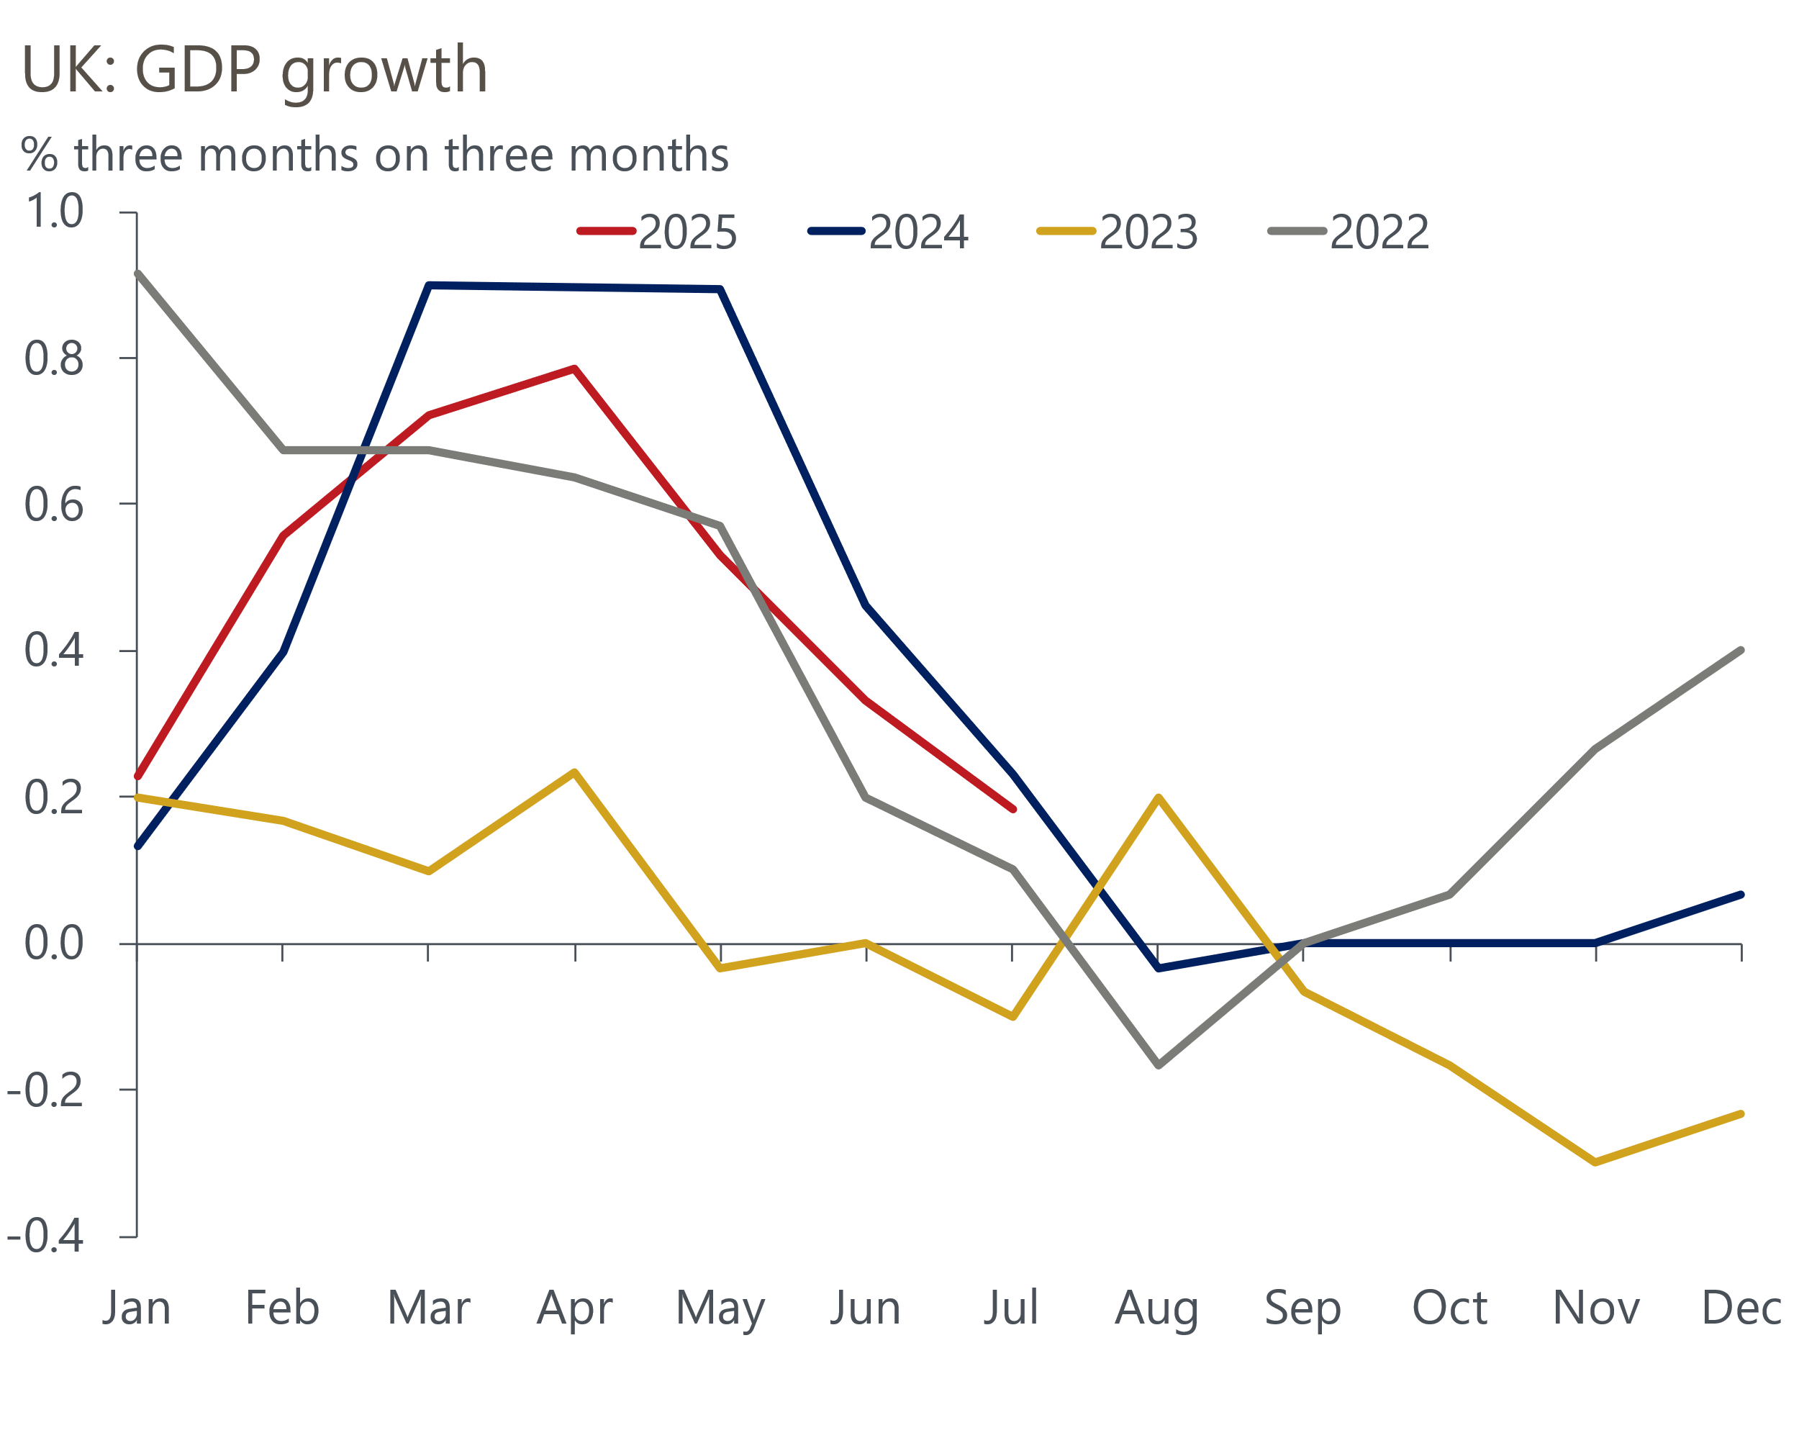
Source: Haver Analytics

The ONS suggested that one reason why there was such a limited impact from the strikes was that the scale of industrial action was smaller than the five days of strikes by junior doctors in June 2024. 7.5% more working days were lost in last year's strikes than this year's ones. But health output contracted by 1.6% month-on-month last June, and we would still have expected to see a chunky fall in output this July.
Stepping back, the evidence that the GDP series is suffering from residual seasonality continues to build. For each of the past three years, the economy's momentum was stronger in the early months of the year before petering out in H2 (Chart 1). So far in 2025, GDP growth looks to be following a remarkably similar pattern. And the likelihood that growth continues to slow – following the pattern of recent years – is increased by the fact that several sub-sectors have now grown very strongly in June and July, so they will likely see some payback soon. Despite July's stronger-than-expected outturn, we expect the economy to eke out only very modest GDP growth across Q3 as a whole.
As we discussed in a Research Briefing published earlier this week, we think the UK economy remains exceptionally fragile and is lacking a sustainable driver of growth. The strength of domestic headwinds is likely to mean momentum remains weak as we move into 2026.
Firms appear to be passing on some of the costs of April's rise in employers' national insurance contributions in the form of higher prices and lower spending on wages and salaries. The combination of cooling pay growth and higher inflation will squeeze real household income growth and weigh on consumer spending power (Chart 2). Some consumers will also have to contend with the lagged impact of past interest rate hikes, as a substantial minority of mortgagors are yet to refinance cheap five-year fixed-rate deals taken out before mid-2022. We estimate that when these borrowers refinance next year, the average interest rate on an equivalent product will be 270bps higher.
Chart 2: After a strong period, household finances are being squeezed by high inflation
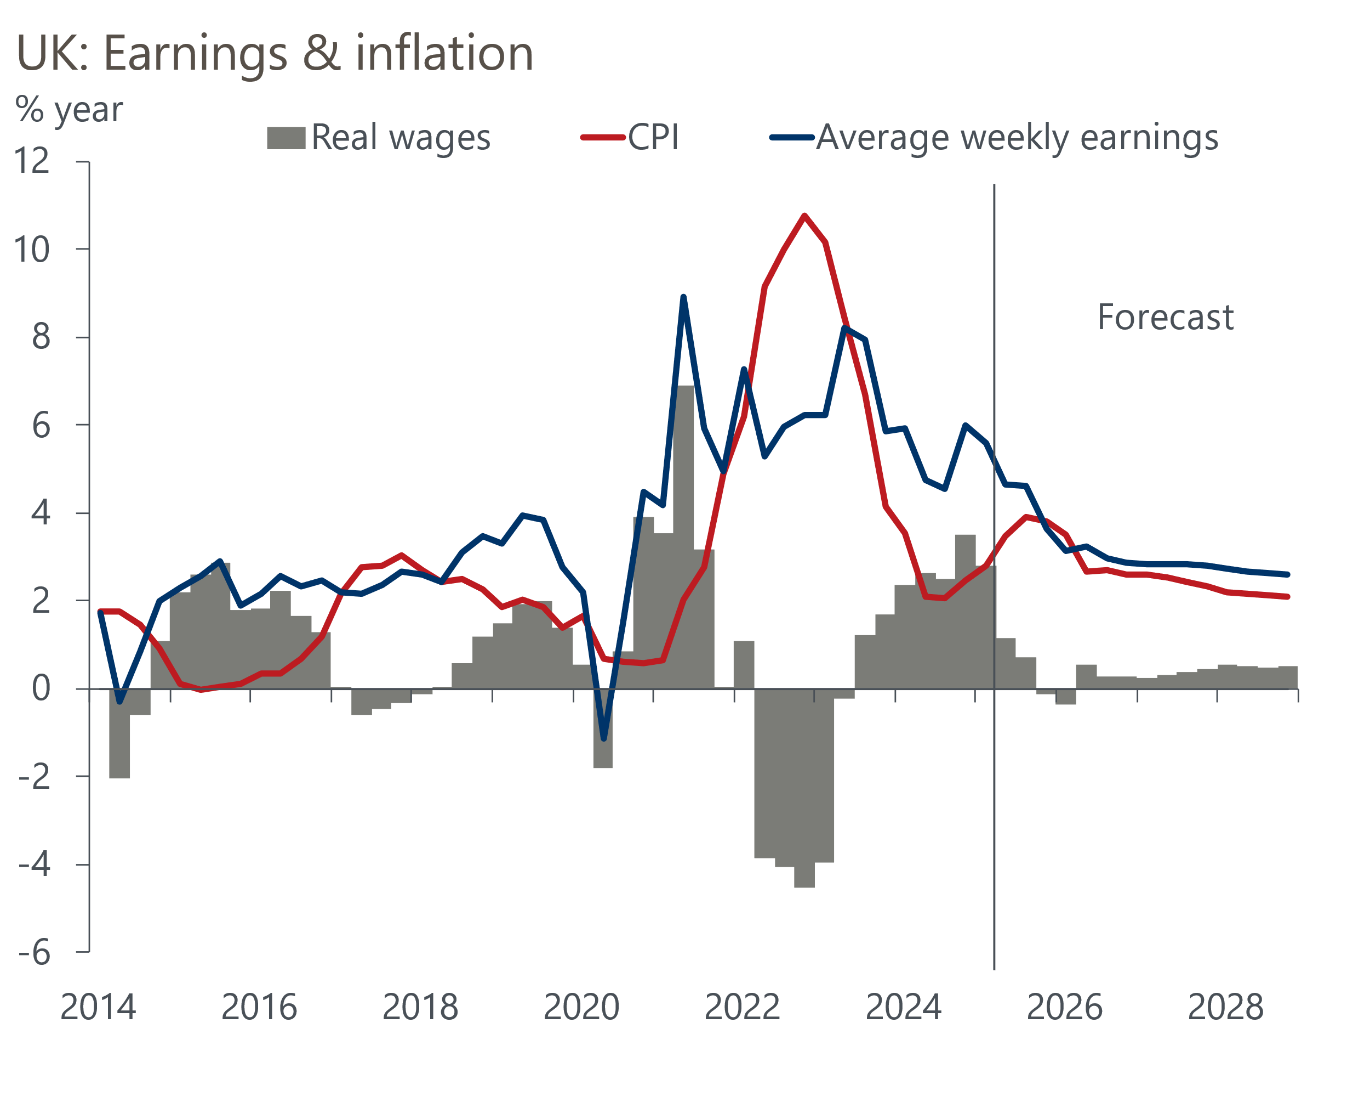
Sources: Oxford Economics, Haver Analytics
Fiscal policy is already being tightened significantly this year and next, but further tax rises look increasingly likely in the autumn. A combination of government U-turns on welfare reforms and winter fuel payments for some pensioners, higher debt servicing costs, and the likely downward revisions to the Office for Budget Responsibility's optimistic potential growth forecasts, suggest the Chancellor will need to tighten policy by around £30bn at her Budget on November 26 to comply with her fiscal rules while maintaining the same slim headroom as the last two fiscal events.
Extending the freeze on tax thresholds beyond 2027-2028 is likely to form part of the savings. But the Chancellor is also likely to re-run the playbook of last year's Budget, raising money through a series of narrowly focused taxes. These will likely bite sooner and add to the drag on growth from tighter fiscal policy. So we remain gloomier than the consensus and think that GDP growth will likely be around 1% in 2026.

The week ahead
Next week's main event is the Monetary Policy Committee meeting for September. Since the start of the rate easing cycle, the MPC has cut at alternate meetings, so we've always viewed September as a 'hold' meeting. This has been reinforced by the committee's hawkish messaging in August and recent data that has failed to deliver major dovish surprises. We anticipate an 8-1 vote to keep Bank Rate unchanged at 4%, with Alan Taylor the sole dissenter.
The MPC will also set the pace of quantitative tightening over the next 12 months. The committee has voted to reduce the stock of gilts held in the Asset Purchase Facility by £100bn in each of the past two years. But with £49bn of redemptions due over the next year, which is much lower than the past year, maintaining the same pace of QT would imply a sharp rise in active gilt sales. Market participants expect the MPC to vote for a lower figure, and given recent volatility in the gilt market, we think the MPC will be keen to avoid an upside surprise. So we expect the MPC to vote to slow the pace of QT to around £75bn in 2025-2026.
Next week will see the release of the labour market data for May-July. We think the slowdown in underlying wage growth continued in the three months to July, so we estimate that regular pay growth cooled to 4.8%. But we suspect base effects from a soft period for bonuses last summer will have pushed total pay growth up slightly to 4.7%.
On the quantities side, the Labour Force Survey measure of unemployment has been stable at 4.7% in the past two releases. Though we expect a slightly higher single-month reading for July, this is unlikely to be enough to shift the three-month average. So we forecast that the unemployment rate held firm at 4.7% in the three months to July.
CPI inflation rose to 3.8% in July, and we estimate that the headline rate edged up slightly further to 3.9% in August. This reflects our view that further upward pressure from food prices and a smaller drag from the petrol category should more than offset the impact of a modest fall in services inflation due to July's temporary spike in air fares unwinding.
The Office for National Statistics revealed that it had delayed the publication of July's retail sales data to correct seasonal adjustment errors. The new profile looks more believable, but remains volatile from month-to-month. We expect July's large increases in non-food and non-store sales will partially unwind in August. As a result, we forecast that total retail sales volumes fell 0.3% m/m in August.
Table 1: Week ahead calendar
Date | Events | Period | Measure | Unit | Previous | Forecast
Sep 16 | LFS unemployment | May-Jul | Rate | % | 4.7 | 4.7
Sep 16 | Average earnings (total pay) | Jul | 3m, y/y | % | 4.6 | 4.7
Sep 16 | Average earnings (regular pay) | Jul | 3m, y/y | % | 5.0 | 4.8
Sep 17 | CPI inflation | Aug | m/m | % | 0.1 | 0.3
Sep 17 | CPI inflation | Aug | y/y | % | 3.8 | 3.9
Sep 17 | RPI inflation | Aug | m/m | % | 0.4 | 0.4
Sep 17 | RPI inflation | Aug | y/y | % | 4.8 | 4.6
Sep 17 | Land Registry house prices | Jul | y/y | % | 3.6 | 3.7
Sep 18 | BoE Bank Rate decision | Sep | Bank Rate | % | 4.00 | 4.00
Sep 19 | GfK consumer confidence | Sep | Headline | % bal | -17 | -16
Sep 19 | Public finances | Aug | PSNB ex | £bn | 1.1 | 11.9
Sep 19 | Retail sales inc fuel | Aug | m/m | % | 0.6 | -0.3
Sep 19 | Retail sales inc fuel | Aug | y/y | % | 1.0 | -0.1
Source: Oxford Economics

Key forecasts
Table 2: UK forecast overview
(Annual percentage changes unless specified)
 | 2023 | 2024 | 2025 | 2026 | 2027 | 2028
GDP | 0.4 | 1.1 | 1.3 | 0.9 | 1.3 | 1.7
Private consumption | 0.5 | 0.6 | 1.0 | 1.0 | 1.2 | 1.7
Fixed investment | 0.3 | 1.5 | 1.9 | 1.0 | 1.6 | 2.0
Government consumption | 1.6 | 3.0 | 1.8 | 1.8 | 1.6 | 1.7
Exports of goods and services | -0.4 | -1.2 | 2.2 | 0.2 | 1.2 | 1.4
Imports of goods and services | -1.2 | 2.7 | 3.9 | -0.9 | 1.1 | 1.4
Industrial Production | -0.8 | -1.2 | 0.3 | -0.4 | 0.8 | 1.2
Consumer prices | 7.3 | 2.5 | 3.5 | 2.9 | 2.5 | 2.1
Unemployment rate (%) | 4.1 | 4.3 | 4.7 | 4.9 | 4.8 | 4.4
Current a/c balance (% of GDP) | -3.5 | -2.7 | -3.3 | -3.1 | -2.9 | -2.8
Government balance (% of GDP) | 5.2 | 5.1 | 4.5 | 3.6 | 3.0 | 2.6
Central bank policy rate (%, EOP) | 5.25 | 4.75 | 4.00 | 3.50 | 3.00 | 2.75
10yr govt. bond yield (%, EOP) | 3.54 | 4.57 | 4.70 | 4.25 | 3.77 | 3.47
Exchange rate (US$ per £, EOP) | 1.27 | 1.25 | 1.33 | 1.34 | 1.34 | 1.34
Exchange rate (euro per £, EOP) | 1.15 | 1.21 | 1.15 | 1.15 | 1.15 | 1.15
Source: Oxford Economics
Table 3: Quarterly forecasts for the UK
 | 2025 |  |  |  | 2026
 | Q1 | Q2 | Q3 | Q4 | Q1 | Q2 | Q3 | Q4
GDP (% year) | 1.3 | 1.2 | 1.2 | 1.3 | 0.8 | 0.7 | 0.9 | 1.0
CPI inflation (% year) | 2.8 | 3.5 | 3.9 | 3.8 | 3.5 | 2.7 | 2.7 | 2.6
Bank Rate (%, EOP) | 4.50 | 4.25 | 4.00 | 4.00 | 3.75 | 3.75 | 3.50 | 3.50
10yr gilt yield (%, EOP) | 4.70 | 4.48 | 4.75 | 4.70 | 4.66 | 4.54 | 4.40 | 4.25
US$ per £ (EOP) | 1.29 | 1.37 | 1.33 | 1.33 | 1.33 | 1.33 | 1.34 | 1.34
Euro per £ (EOP) | 1.20 | 1.17 | 1.15 | 1.15 | 1.15 | 1.15 | 1.15 | 1.15
Source: Oxford Economics

Latest Country Economic Forecast:
August 20, 2025

Recent publications

Data Insights
GDP was flat in July and underlying conditions remain weak
Retail sales rose in July, but data quality concerns dominate
Stronger services PMI probably overstates GDP growth in Q3
August's PMI pointed to a renewed fall in manufacturing activity
Lower mortgage rates continue to support lending activity

Research Briefings
MPC preview – Pace and shape of QT is likely to be tweaked
What could prompt the BoE to cut further and/or faster?
Stagflation-lite as policy headwinds increase turbulence
Why is services inflation sticky despite slowing pay growth?
Tight BoE vote to cut casts doubt on the path for rates

Contacts

Oxford Economics' UK team
- Andrew Goodwin - Chief UK Economist - agoodwin@oxfordeconomics.com
- Edward Allenby - UK Economist - eallenby@oxfordeconomics.com

